**ASSIGNMENT: HOMEWORK 9 – BUSINESS INTELLIGENCE**

**NAME: STEPHEN OMONDI**

**NET ID: SOOMONDI**

**DATE: Friday, March 20, 2020**

**Screenshot Northwind_Sales.xlsx pivot table**

**Screenshot of Northwind-Sales.pibx – showing daily sales by employee slice.**

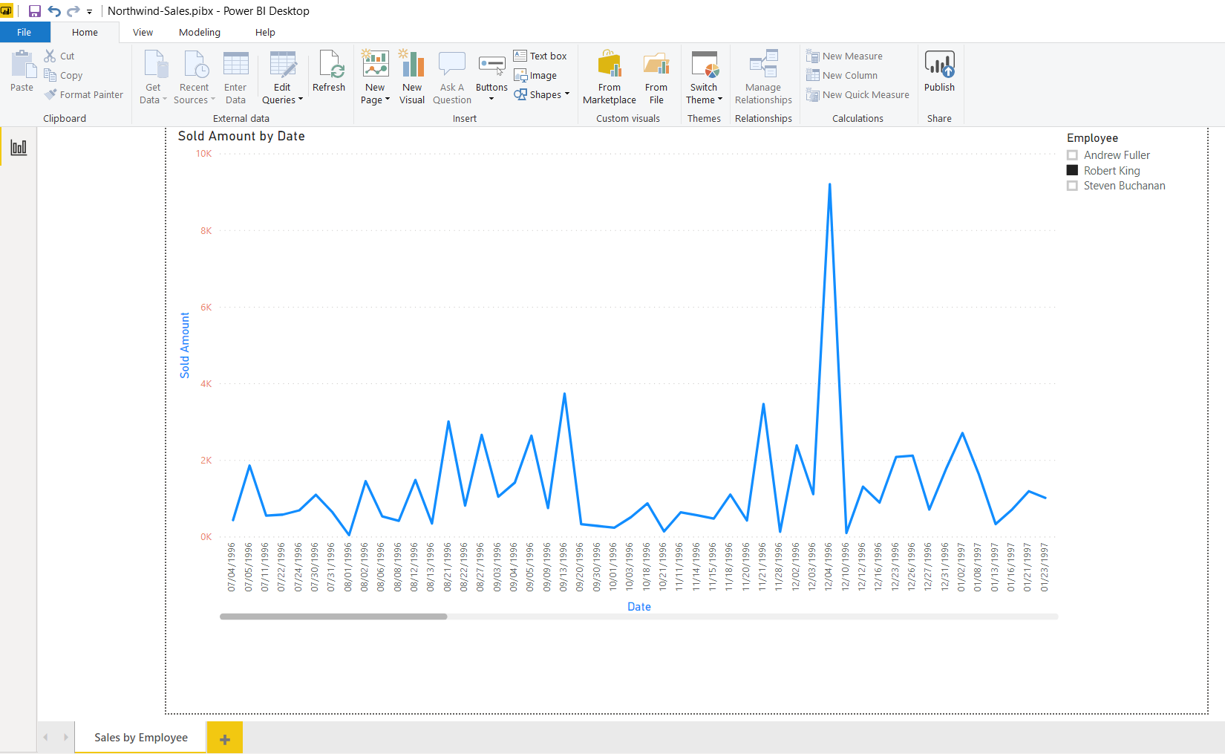

**Northwind Sales Cube**

